Machine Learning in Signal Processing

Jose C. Principe

Distinguished Professor of Electrical Engineering

University of Florida

This talk describes our efforts to go beyond the second order moment assumption still prevalent in optimal signal processing. We show how the second norm of the PDF can be estimated directly from data avoiding an explicit PDF estimation step. The link between PDF moments, information theory and Reproducing Kernel Hilbert spaces will be established. Applications to adaptive systems with entropic cost functions will be demonstrated. A generalized correlation function called correntopy will be defined and its applications in signal processing will be outlined. Correntopy leads to new measures of similarity, to a new definition of dependence subspaces and to new tests for causality.

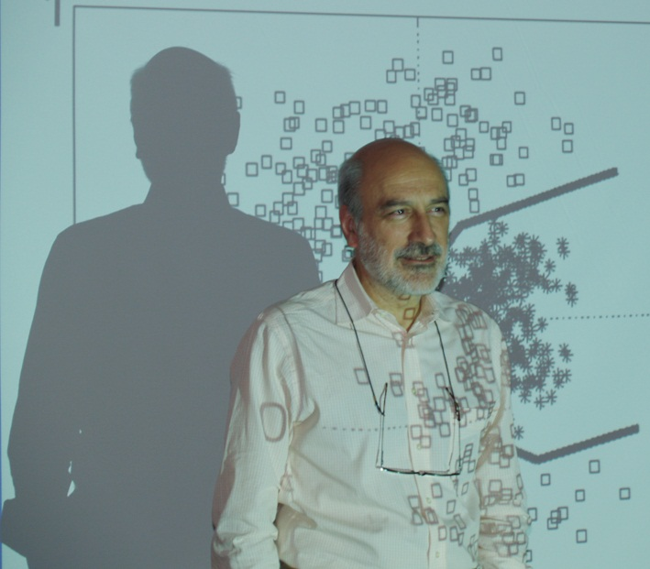
Jose C. Principe (M’83-SM’90-F’00) is a Distinguished Professor of Electrical and Computer Engineering and Biomedical Engineering at the University of Florida where he teaches advanced signal processing, machine learning and artificial neural networks (ANNs) modeling. He is BellSouth Professor and the Founder and Director of the University of Florida Computational NeuroEngineering Laboratory (CNEL) www.cnel.ufl.edu . His primary area of interest is processing of time varying signals with adaptive neural models. The CNEL Lab has been studying signal and pattern recognition principles based on information theoretic criteria (entropy and mutual information).
Dr. Principe is an IEEE Fellow. He was the past Chair of the Technical Committee on Neural Networks of the IEEE Signal Processing Society, Past-President of the International Neural Network Society, and Past-Editor in Chief of the IEEE Transactions on Biomedical Engineering. He is a member of the Advisory Board of the University of Florida Brain Institute. Dr. Principe has more than 500 publications. He directed 62 Ph.D. dissertations and 65 Master theses. He wrote in 2000 an interactive electronic book entitled “Neural and Adaptive Systems” published by John Wiley and Sons and more recently co-authored several books on “Brain Machine Interface Engineering” Morgan and Claypool, “Information Theoretic Learning”, Springer, and “Kernel Adaptive Filtering”, Wiley.

